**ME-18 Final Project Report**

Professor Huang

Instrument/Experiments

By: Adolfo Castillo, Lorenzo Salgado, and Walker Wind

Table of Contents

Project Introduction 3

Methods 3

Results 4

Impact and Conclusion 8

Logbook Appendix 10

Entry 1: 10

Entry 2: 11

Entry 3: 12

Entry 4: 13

Entry 5: 14

# Project Introduction

This experiment will focus around the game of cornhole. The fundamental question that will be answered is, what are the optimal parameters for the perfect cornhole throw? This question spiked interest from us considering that we all enjoy taking part in a good game of cornhole. As we get to know our way around the game of cornhole, we want to investigate what factors make for the optimal bean bag toss. We will be taking into account multiple parameters, including launch velocity of the bean bag, launch angle, and the type of throw used (underhand or overhand).

From the searches that we conducted at the start of our project, there does not seem to be many studies showing the optimal way to throw a bean bag to score consistently in cornhole. However, people who play competitively seem to have come to an agreement that an underhand throw is the most optimal throw to win. This is not backed by any data, besides their own experience. We hope to gather data and either prove them right or find out that they might actually be wrong, and an overhand approach might be better to score consistently.

# Methods

Due to the COVID-19 pandemic that occurred at the time of data gathering, we were forced to switch to less traditional data gathering systems than we had previously planned for. We could no longer use equipment found at Tufts University, so we transitioned from using an Arduino set up, so using video processing software. Because we could no longer work together physically, a member of our groups was assigned the task of taking all the videos with his own cornhole setup that he had at home. Those videos were then shared with the other two members of the groups who took over most of the analyzing and gathering of data from the videos.

The videos analyzed showed a person throwing the bean bag. With the camera focused on the arm motion and at the time of release. Each throw was documented and measured to see how far away it was from the intended target. Due to the nature of how sensitive the video processing software we were using was, the videos had to be recorded in front of a darker background in order to have a good color contrast between the bean bag and the background. This helps the videos software follow the bean bag as it moves in the swing. Allowing us to gather more accurate results.

We used Kinovea, a sports video analysis software, to measure the angle of launch and initial velocity of each beanbag. While this software is very useful for finding the angle, we had a hard time getting an accurate launch velocity. As a result, we found that the velocity measured in Kinovea was higher than the actual velocity. When trying to determine the error that is present in our experiment, we investigated the effect that drag would have on a bean bag. The graph below comes from an online calculator, that shows the difference between a throw in a vacuum and a throw with drag. For reference, the mass of the bean bags was about .45 kg. Though the properties of the object thrown are different, they are close enough to demonstrate that objects with a weight greater than or equal to 300 g and the size of the object is slightly different, the trajectory of an object in a vacuum is almost identical to an object with drag.

# Results

After recording all of the data points, we used MATLAB to explore the relationships between variables, the performance of the thrower over time, and the velocity discrepancies due to our video analysis software, Kinovea.

When we were analyzing videos in Kinovea, we noticed that the velocities we were recording were higher than they should have been. By plugging in the initial conditions to a trajectory calculator, we found that the recorded initial velocities would give us a distance of over 10 m farther than the actual landing locations. To see why this was happening, we investigated the effect of drag and saw that it would have a negligible effect. We determined that the reference geometry in our video could be incorrect, but after adjusting the reference geometry found the velocity to still be too high. Though we couldn’t figure out exactly what caused the error, we were able to demonstrate the effect of velocity on the error and how we would need to scale the projected velocity to match the actual landing position. Hypothetically, if we collected enough data about the scaling, we could use the scaling to correct the projected velocity if we wanted to predict a landing location given initial height, velocity, and angle.

We also explored the discrepancies between the measured distance from each throw and the modeled distance based on the determined throw parameters from Kinovea. A paired two sample t-test at 95% confidence was able to decide that the means were not are not the same (t-stat = -24.068, p < 1.2698e-21). Correlation plots were produced for actual vs predicted performance data, as well as plots for performance over time. The plots for x-distance (Fig.4) over time showed a weak linear trend, as well as that of the y-distance (Fig.5) and radial distances (Fig.6) from the target. The plot for predicted range of throw vs actual range (Fig. 7) showed no correlation (R-squared = 0.027). Neither were able to produce useful patterns to the benefit of our original aim, but they all but confirmed the existence of error in our experimental data collection.

Due to unforeseen circumstances, the original scope of the project had to be reimagined and reduced. Motion-capture data from video is a rather novel concept compared to our originally intended method of data collection in sensors (accelerometer, gyroscope, etc.) that would have been used in a controlled environment instead. This would have allowed for an efficient and accurate collection of relevant parameters of projectile motion, with fewer unpredictable errors.

Theoretical errors in our models were explored, namely unaccounted drag forces from the wind. Following research, we concluded that drag forces are not present at the given throw speed, mass, and surface area of the beanbag. The primary instrumental error stemmed from applying incorrect reference geometry in Kinovea outside of the plane of the throw. Even after correction, error was still present, though quantified to a degree (Fig.3)

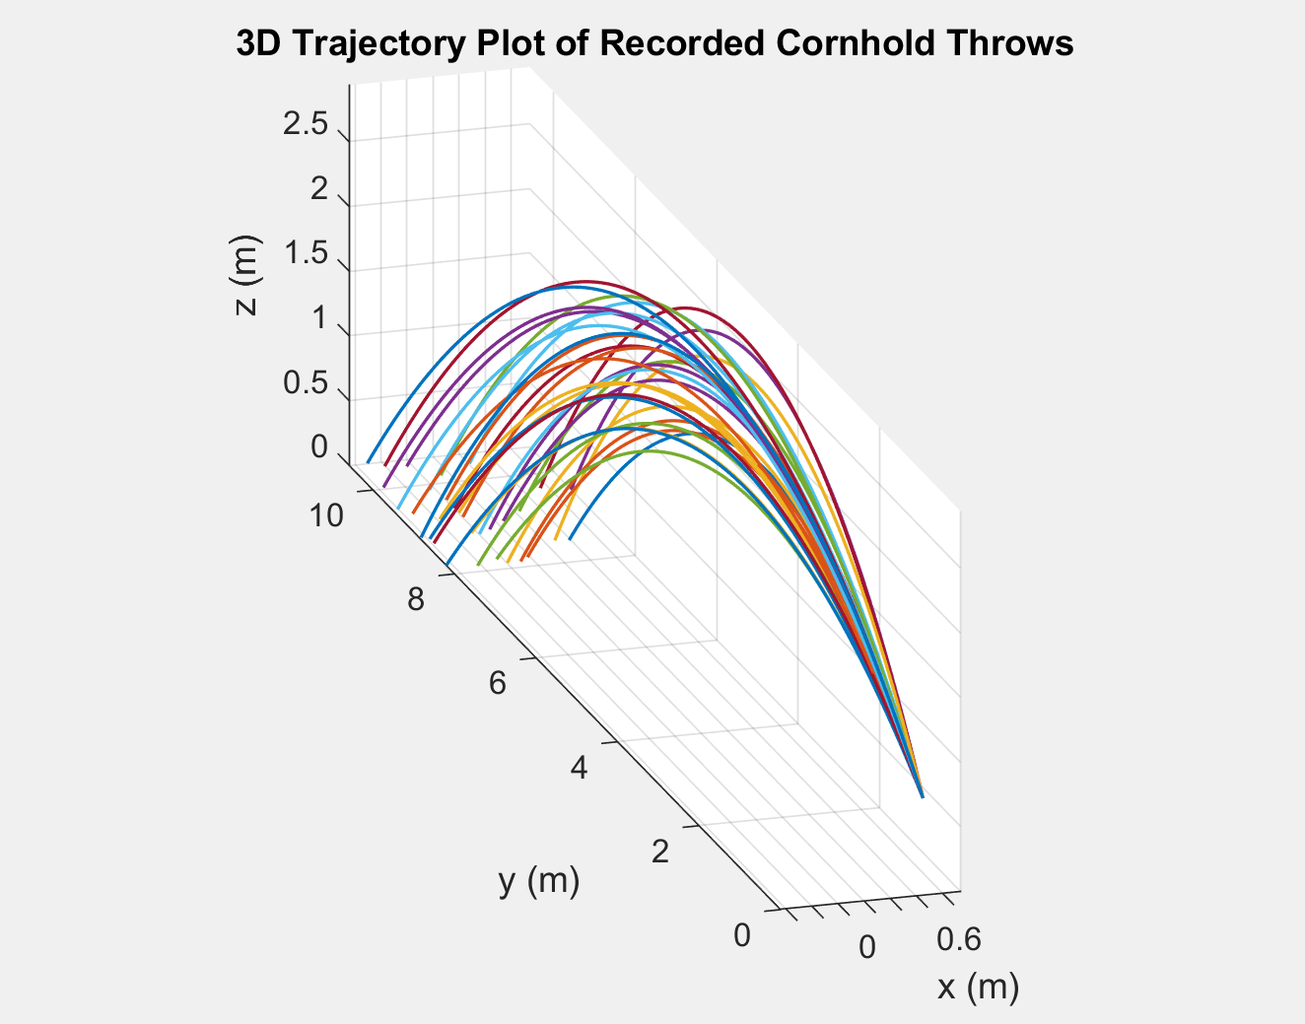

*Figure 1: This figure shows the 3D plot of the approximate trajectories of all 32 throws that we recorded. Because the recorded velocities were inaccurate, we found the actual initial velocity by using the landing location and angle to solve for the initial velocity. Once we had the initial velocity, we could plot the trajectories of the bean bags. We only recorded the path of the bean bags in one direction, but we can assume that the top view trajectories are linear given that gravity is not affecting the motion in that plane.*

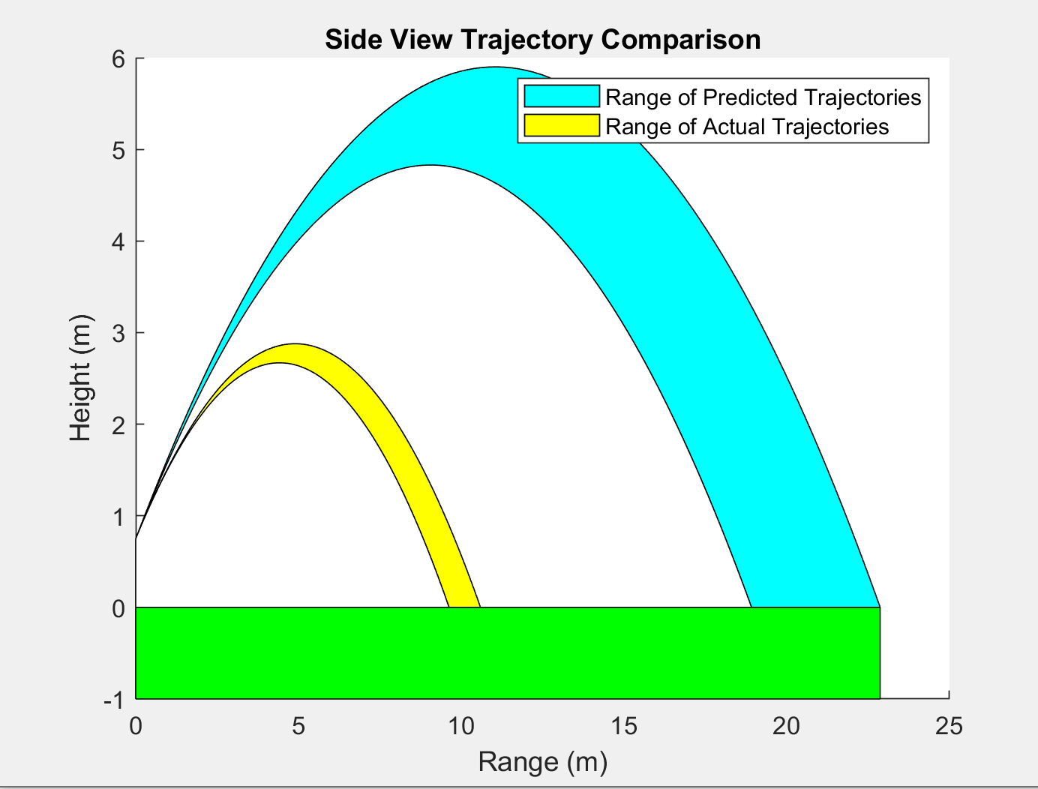

*Figure 2: The graph above is a side view of the trajectory above. However, this graph displays the difference between the trajectories we predicted using kinovea and the actual trajectories. Obviously, the prediction is very far from the truth. Because the initial velocity has a squared relationship with the landing position, small errors in the velocities are magnified.*

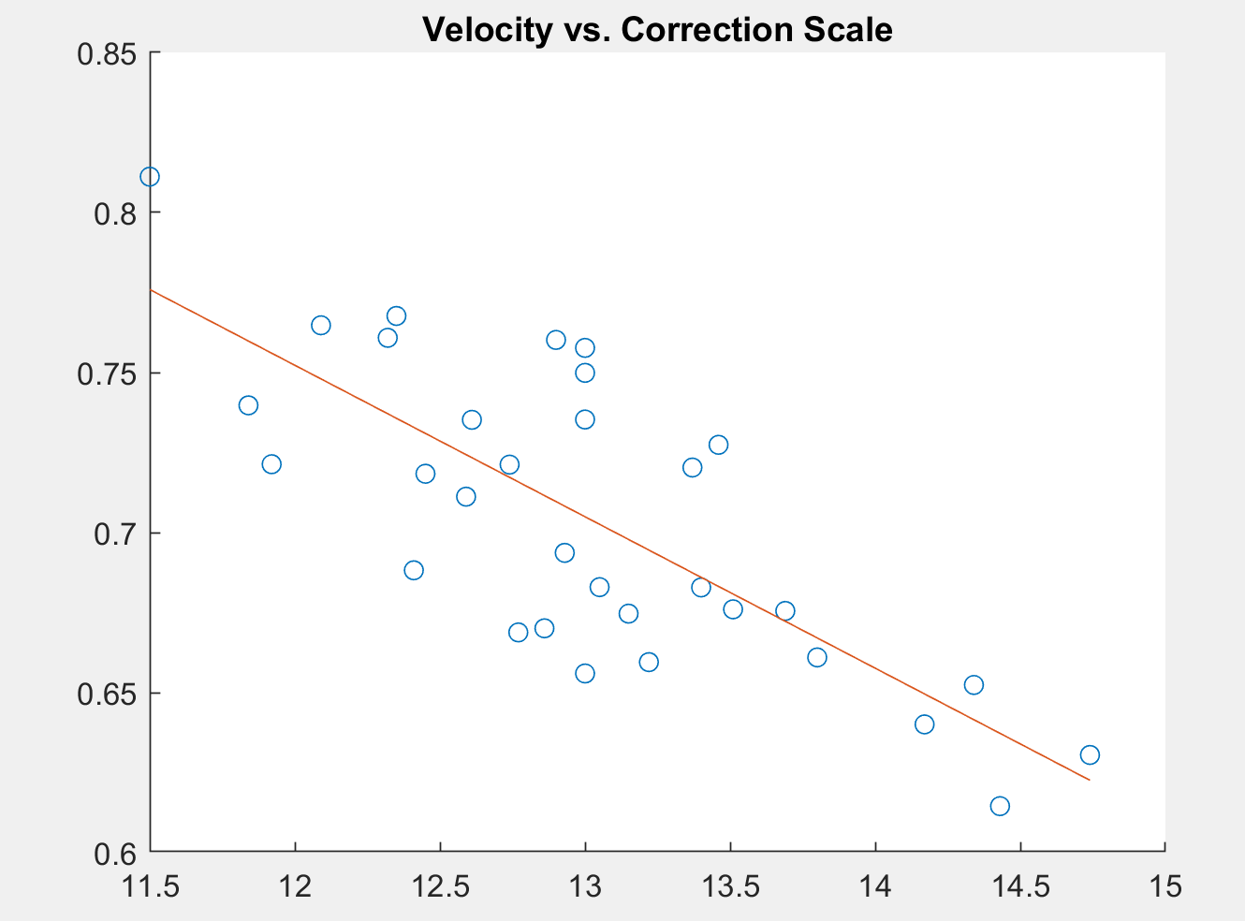

*Figure 3:* This figure shows the relationship between velocity from kinovea, on the x axis, and the scaling factor needed to correct the initial velocity. As the graph demonstrates, we observed that when the velocity is increased, the proportion between the actual and kinovea velocity becomes smaller. This means that the error increases proportionally to the velocity.

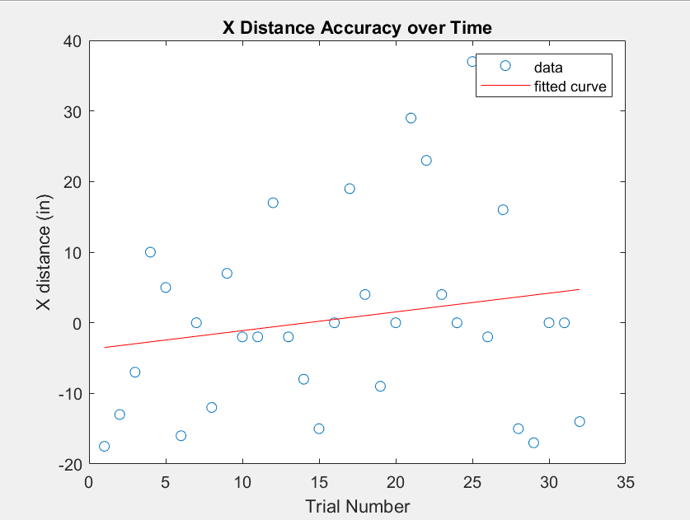

*Figure 4: The accuracy in the X direction shows that there was not much improvement in the throws over time. The later trails seem just as inaccurate as the first couple of trials. However, after adding a fitted line, we can see that there might be some actual correlation. The thrower began throwing a little to the left and as time went on they started throwing to the right. With more data points we could potentially see a better trend of improvement.*

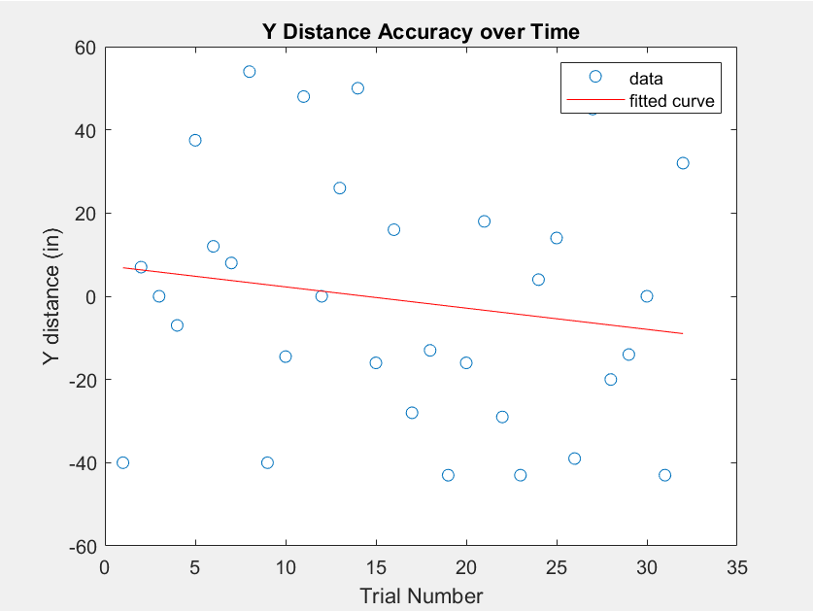

*Figure 5: The accuracy in the Y direction shows that there was not much improvement in the throws over time, just like in the X direction. However, with the trend line added, we see that the thrower started by overshooting the target, then adjusted, but began undershooting it. Just as in the X direction, with more data points we might be able to see a better correlation.*

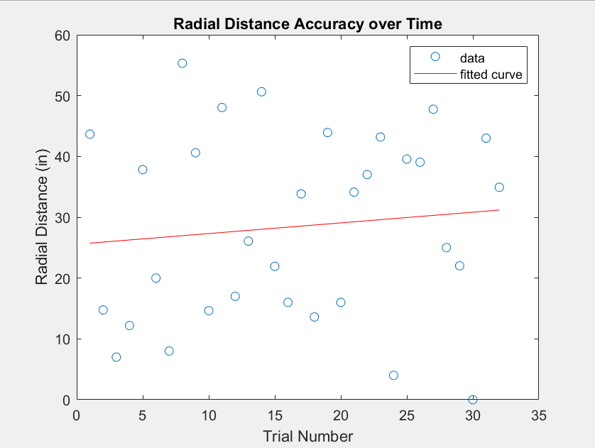

*Figure 6: The accuracy in the radial distance as the trials increase shows that there is almost no correlation between the radial distance and the trials. The fitted line is almost horizontal with a small tilt, indicating that from the data points that we gathered, the thrower is actually getting worse with each trial. Due to these points, we can say that there was no improvement over time.*

Two Sample Student’s T-test for Difference of Means between Modeled Toss vs Measures

|  |  |  |  |
| --- | --- | --- | --- |
| Degrees of freedom | p-value | t-statistic | Confidence Interval (95%) |
| 31 | 1.2698e-21 | -24.0683 | [-9.1154, -7.6912] |

*Table 1: The miniscule p-value and large t-statistic indicate a strong rejection of the null hypothesis that there is no difference in the means of the predicted throw distance from kinematics vs actual throw distance. At a 95% confidence interval, the difference of means is described by the confidence interval. We accept the alternate hypothesis that the means are significantly different.*

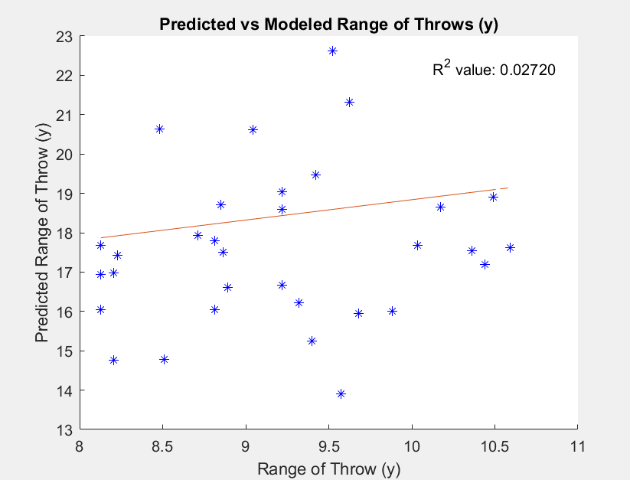

*Figure 7: The above scatter plot shows the total distance travelled along the y-axis of the cornhole board for actual trials vs our modeled trials.The R-square value of 0.0272 is exceptionally low and suggests a really weak correlation exists between our model and actual trials. In the y-direction, the cornhole bean bag is subject to several factors which may explain the low correlation value. As a group, we discussed the effects of wind drag, data collection methods, and variability of the thrower as possible sources for this discrepancy.*

# Impact and Conclusion

Understanding the optimal throw of a corn hole toss could impact the way the game is played up to a professional level. Although in this experiment we were not able to gather the results that we had anticipated, this experiment itself could serve as a way for other competitive sports to be viewed differently. If we could have reduced some of the errors that we encountered, have better equipment, along with having many more points of data, we could have been able to actual data proving that some cornhole throws are better than others. This type of experiment could potentially be applied in other ways as well. For example, this type of experiment could be used in finding what is the better posture for a football to be thrown with better accuracy.

Though I am sure many scientists have analyzed the aerodynamics of balls in sports, people have not really analyzed how to win at cornhole because it is a backyard game and there is no money or fame in cornhole, so there has never been a practical need to use technology to improve the way cornhole is played. However, we think that our project is a fun demonstration of analyzing projectile motion. If our project had been at school, we would have had a more efficient data collection procedure that would allow us to take much more data and identify trends in a large dataset. We could have even used the data collection to give live feedback to throwers about how they could improve their throw.

We found that using video software may not yield the best data for measuring the speed of the throw, but if we had an accurate measurement of velocity for the beanbags, we could use kinematics and predict the landing spot given only the throwing video. It would be a very interesting demonstration of data analysis and video processing if we could write a program to predict the probability of success based on the parameters from the video.

In doing this project, we developed a testing procedure that can be adapted for many other sports This type of experiment would be able to be used in multiple other sports: baseball, basketball, tennis, etc. Using better equipment and processing programs, sport teams could find what is the optimal swing, toss, throw, and hit for their players. It could revolutionize how well the player scores, and this would in turn potentially affect the earning of many people considering that sports leagues are a multi-million-dollar industry. If this type of analysis were to grow to this bigger scale, the probability that there would be engineering breakthroughs to make these tests more accurate would be high. Taking into consideration that sports teams would want to have an advantage, they would hire the best engineers and scientists to develop new ways to analyze this type of data.

Overall, this project was an exploratory investigation of cornhole, and we could apply the data we collected to find trends, assist cornhole throwers, and maybe even develop a model to use for a cornhole throwing robot. We learned a lot about how easily data can be recorded using only your phone and software. Though we would have liked to have more data to work with, we were still able to conclude that cornhole is a sport with a lot of variability. For people that aren’t professionals, it is very difficult to be consistent in your throwing.

# Logbook Appendix

## Entry 1:

**Walker**

**Date:**

For the first week, I worked on setting up a testing station and capturing videos. It took some time for me to get a hold of cornhole boards and set up a regulation field in the yard that I had access to. My role in the project is to collect the cornhole video data and process it. Because my partners can’t collect data, I am responsible more for upfront work and they will spend more time on the backend analyzing the data that we collected.

Once I had a regulation set up, I recorded several videos to analyze. One or two of the videos I took were of a friend throwing a beanbag from up close, and the other videos we took were a wide shot of the trajectory. I played around in Kinovea to see how easily the video could be analyzed, and found that there were times when the software had trouble tracking the full path of the beanbag.

**Hours worked: 4**

**Adolfo**

**Date:** March 30th, 2020

After meeting with Martin, he recommended that we use a video software called Kinovea. This week I familiarized myself with how to use it and it’s useful tools. I used a test video that Walker has sent us of one of his friends throwing a bean bag and I used this video to practice tracing the path of the object as it was let go from his hand.

**Hours worked:** 2hrs. 30min.

**Lorenzo**

**Date: 3/30**

Researched possible MATLAB visualizations from a previous personal kinematic motion project. This is a Graphical User Interface that models simple projectile motion using initial launch angle and velocity as inputs. Since we are looking to test the variability and repeatability of a human with corn hole throws, a possible modification could be predicting whether any one throw would be successful based on random error we find from video analysis.

Kinovea Version 0.8.27 was decided as the software used for video analysis. A large part of the allotted lab/work time was spent learning tools Kinovea possesses (path tracking, setting reference lengths, etc), to best process our video data of cornhole throws.

**Hours worked:** 2.5 hr

## Entry 2:

**Walker**

**Date: April 6th**

After discussing the results with my teammates, I took a round of videos with a more precise set up. For each throw in these videos, I recorded the x and y distance from the center of the cornhole that the bean bag landed, the score of the shot, and some other statistics. I only had the chance to take about 12 trials, since the data takes a long time to record. My goal this coming weekend is to record as much data as possible for us to analyze.

After talking about the videos and trying to analyze the videos in Kinovea, we decided I needed to take slow motion videos to make the tracking more accurate. The beanbag is moving at a high speed, and sometimes kinovea will lose the path of the beanbag because of it. We also determined that we didn’t need to track the whole trajectory of the beanbag, and that we are just looking for a launch angle and initial velocity when it leaves the hand.

For now, we are going to analyze some of the raw data videos we had from the first round of throws just as a test to see if we can produce data from it. This data will probably not be used in the final product, but as practice for getting to know the software.

Analyzing this week’s graphs: From what I can tell, the dataset isn’t large enough to have any noticeable correlations. Though, I can tell that there is a definite amount of random error that we will need to account for. I will be most interested to see how the speed of the throw affects the vertical distance from the throw, and statistics about what speed will achieve more scoring. I think that from an engineer’s perspective, we think about how physics is affecting the bean bag, but we are trying to observe more about a human’s ability to throw reliably.

**Hours worked: 3**

**Adolfo**

**Date:** April 6th, 2020

This week we tested Kinovea with actual videos of Walker throwing the bean bag. After talking as a group and seeing how Kinovea interacted with the videos. We decided that taking slow-mode videos on an iphone would be easier for the video software to pick up the object as it moved. I was able to run Kinovea with one of the videos that Walker created successfully and found the velocity of the bag as it left his hands as well as the angle. We hope that we will be able to do this with future videos.

This week I also took a couple of more videos that Walker took and processed them through Kinovea to get the desired data. As mentioned before, Kinovea lets us gather data from the motion of the bean bag. So far, I have been able to get velocity data as well as angles from most of the videos that have been created.

**Hours worked:** 3hrs

**Lorenzo**

**Date:** April 6th, 2020

Experimented with video color correction to increase contrast of beanbag against video background, as sometimes there was trouble for Kinovea to track the full path of the beanbag. It was determined that Kinovea is very particular about the files it can work with. Since no editing processes would allow us to make video data easier to process, we determined that raw video would have to be used.

Alternate methods were discussed, such as utilizing the slow-motion video feature on iPhone devices as there are a greater number of frames for Kinovea to analyze. However, some data was able to be processed and produced some plots below.

**Hours worked:** 3 hr

## Entry 3:

**Walker**

**Date:** April 13th

For this week, I collected throw data with my dad and then helped analyze the data. I also am producing some charts of the throwing data surrounding the landing position of generating statistics about that.

I collected throwing data in the following setup. The cornhole boards followed regulation standards, with the two boards 27 ft apart and parallel. Each of the beanbags is about 1 pound, and the thrower was kept constant for this set of trials. I took data in batches of four, stopping after four had been thrown to measure the x and y distance of each beanbag to the center of the hole in the cornhole board. At the start of each throw, I recorded the motion of the thrower throwing the beanbag using the slow-motion camera on my iPhone, shooting at 240 FPS. There was a total of 32 throws. One thing to note was that there was wind outside while we recorded the throws. If we were in other conditions, we would be recording the throws indoors and using cameras to measure the exact distance from the center of the cornhole board.

I uploaded 32 videos to the google drive, and all three of us analyzed the videos to see the launch angle and velocity at the time that the bean bag is released. Once I did this, it got me thinking about how the force of wind might be affecting the velocity of the beanbag, because solving for the kinematics of the beanbag without any wind effect predicted beanbags to land considerably farther than they should have. We recorded all of the data and are making charts of different variable correlations, as well as plotting out all of the bean bag landing locations and showing average throw, with standard deviation.

**Hours worked: 4.5 hrs**

**Adolfo**

**Date:** April 13th, 2020

Today, along with my other group members, we analysed more videos that Walker took. These new videos had a darker background and were taken in slow motion. These two changes in the way the videos were taken made it easier for Kinovea to track the bean bag as it was thrown and follow its path afterward. As a group we analysed each individual video, a total of 32 videos. Lorenzo and I went ahead and did most of the analysis since Walker took all the videos for us. To initialize the process of the video analysis, we open the video in Kinovea. The next step is to set a reference dimension somewhere on the video using the line tool. After that, you right click on the object you want to track and configure it with your own specification. In the configuration window you can set what info Kinovea can give you. In our case we want Kinovea to output the speed of the object. The angle is then set by using the angle tool, and tracing out the path of the launch.

**Lorenzo**

**Date:** April 13th, 2020

To help correct the issue of contrast between the beanbag and background, a physical solution was reached in terms of covering the background with dark blue sheets and using a bright white bean-bag for each toss. This seemed to solve most issues with Kinovea’s “Tracking” feature. Additionally, we found using the iPhone’s built in high speed video capturing feature useful as it records in 240 frames per second vs the default 60 frames per second. Since the working portion of the video was limited to the action of a toss, having as many frames as possible in such a short time frame provided more accurate data. However, this does not account for experimental error such as unexpected wind/drag forces, fatigue of the thrower after a large amount of trials, or adjustments made between trials in efforts to produce successes.

Once in Kinovea, a process for simple repetition was developed for efficiency of analysis. Upon opening a video file, the seven foot fence in the background was used as the reference length measurement. Kinovea then automatically converts the units of the tracking speed from pixels/second to meters/second. At the instance of the beanbag at release, it is possible to overlay an angle measurement to determine the launch angle. The launch speed and angle data was then manually entered to a spreadsheet for every throw.

We tested a sample of values with simple kinematic equations for horizontal distance and found discrepancies with the experimental values vs the modeled values. It would be interesting to see if any correlation with the differences between modeled values vs measured values exist and if the error could be quantified from the difference.

**Hours worked:** 3.5 hr

## Entry 4:

**Walker**

**Date:** April 20th

As finals are approaching and our workload in classes has gotten much higher, I did slightly less work this week. After exporting data to Excel, I spend a lot of time trying to create a nice looking graph of the landing locations of all the bean bags. Our group has been talking about what questions we want to answer with our data, so I have been brainstorming possible questions to answer. Some that come to mind include: How random is a cornholer’s throw? How fast does a player improve? Can we predict the wind effect on the bean bag using kinematics? I also think it is useful to produce as many informative graphs about the throwing that we can. Even though I wish we had more points to plot, there is still enough data to identify certain trends.

**Hours worked: 3 hrs**

**Adolfo**

**Date:** April 15th, 2020

Today I worked on creating draft paragraphs for the Introduction and Methods section of our final report. I tried being as detailed as possible on each of these sections. We will continue to edit it and add to it as a group.

**Hours worked:** 4hrs

**Lorenzo**

**Date: April 30th**

We met as a group to discuss how we’d break up the data analysis to show trends we hypothesized would be present in our data. In my case, I was to attempt to describe the discrepancy between actual throw distance and predicted throw distance from a kinematic model from the initial launch conditions. Our leading theory was that the difference would be clearly described by a wind drag force.

**Hours worked: 1.5**

## Entry 5:

**Walker**

**Date:** May 2nd

This week, I used MATLAB to make a graph of the same plot of landing spots, except more aesthetic in MATLAB. I also wrote a MATLAB script that predicted landing locations for all the throws based on their initial velocity and angle.

I also worked on creating graphs with shaded regions that show the range of possible projectiles. I researched how drag affects projectile motion

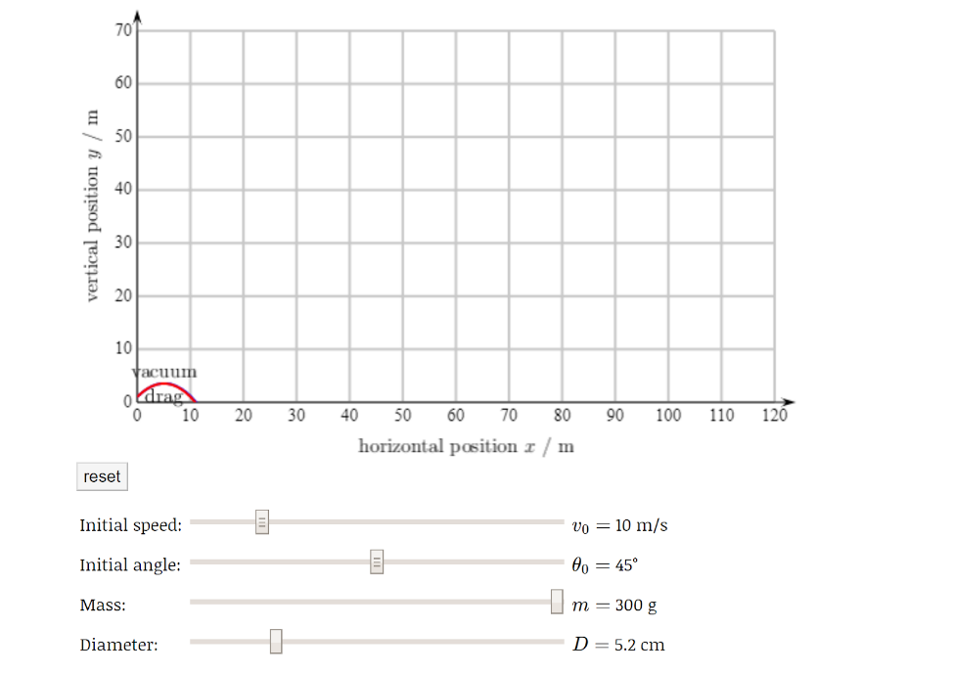

**Hours worked:** 4.5 hrs

**Adolfo**

**Date:** April 30th, 2020

Today we went over the data that we had, and we discussed what would be the best way to move forward. We tried to see if there was any correlation between the velocities the bag was thrown at and the radial distance. What we found from plotting those two values was that there was not much correlation. We also imputed the launch velocities and angles into a projectile motion online calculator and found out that the actual distance that it traveled was not matching with what the calculated distance was. This made us realize that we had used an incorrect reference measurement on Kinovea, and we had to fix our velocity readings by a scale factor. To do this, I took a measurement that was close to the same plane as the bean bag instead of something in the background. I used the thrower’s leg length, 0.48 meters. This gave us more reasonable launch velocities than before.

**Date:** May 3rd, 2020

Today I met again with my group to discuss more about how we would be analyzing the data. We were each assigned set data to analyse and come to a conclusion based on what we found. I was assigned to find out whether from the data we gathered, if we could infer that the thrower improved as the trial increased.

**Date:** May 4th, 2020

Today I analyzed the number of trials vs. the radial distance from the hole. I also correlated the trials with the x and y distances from the hole. What I found was not much correlation from any of the distances that I analysed. I believe that with more data points we might have seen a better correlation, but from the data I looked at, there does not seem to be much correlation. We cannot determine if the thrower improved over time. I placed a line of best fit over the data, and the line seems to show a small correlation, but not enough to say with confidence that there is any.

**Hours worked:** 3.5 hrs

**Lorenzo**

**Date:** May 3rd

When researching kinematics for wind drag, we got unusual results in MATLAB plotting leading us to question the validity of wind drag in our experimental scenario. After further research, we concluded that the conditions for a considerable drag force (high wind speed, small surface area, mass,etc) were not met. This led us to identify Kinovea’s calculations as our primary source of error. This might have been a result of the reference length not being in the same exact plane as the y-direction of the throw. An idealized set-up would have produced a larger amount of useful data with minimal variation in camera angles and a confirmed reference length.

**Hours: 3**

**Date:** May 6th

Met with group members and Martin. Came to the conclusion that the best way to display our data was through a narrative explaining our data collection methods, disruptions in project design stemming from the covid-19 outbreak.

Kinovea tutorial video tutorial was recorded, edited and captioned. Downloaded OBS Studio, an open source screen recorder, and Shotcut, an open source video editor. Had to do multiple takes in OBS before realizing I needed to select the option for full screen recording if I wanted right-click dialog windows to appear in the recording. Once in Shotcut, I opted for captions rather than narration due to lack of a quiet space to record lines for the tutorial. Adolfo will work on putting the video together, alongside with a set-up video from Walker.

**Hours worked: 2.5**